**Who Were the Wright Brothers?**

**Wright Brothers National Memorial**

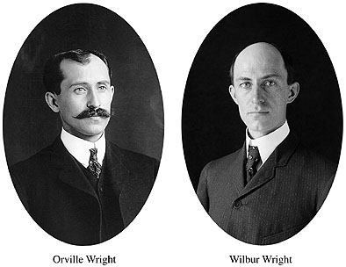

**Location:** Classroom

**Grade:** 4th Grade

**Subject:** Social Studies, ELA

**Duration:** 1-2 Class periods

**Key Vocabulary:** Print Press, Glider, Typhoid

**North Carolina State Standards: 4.H.1.3** Explain how people, events and developments brought about changes to communities in various regions of North Carolina. **4.H.2.1** Explain why important buildings, statues, monuments, and place names are associated with the state's history **W.4.9** Draw evidence from literary or informational texts to support analysis, reflection, and research.

**Materials:**

Timeline Handout

Read Aloud Book

Wright Brothers Photo

**Suggested Books:**

*The Wright Brothers Glider* by Gerry Bailey & Karen Foster

*The Wright Brothers* by Mike Venezia

*Who Were the Wright Brothers* by James Buckley Jr.

**Site Significance**

The historical events leading up to the Wright brothers first flight in Kitty Hawk, North Carolina changed the world and transportation forever.

**Objectives:** The student will be able to order events from the Wright brothers lives and discuss how the student’s

**Essential Question:** How do events from the past affect your life today?

**Method:** Students will order events in the lives of the Wright brothers in order to produce a timeline.

**Background:** The Wright brothers, two young men from Dayton, Ohio came to Kitty Hawk, North Carolina in search of the perfect place to test the first powered aircraft. They faced the challenge of finding a way to control flight. The Wright brothers accomplished the first man powered and controlled flight in history in 1903. This historic event was the first step in many aviation milestones over the years that would greatly impact and change the world.

**Suggested Procedure**

**1.** Introduction- Begin by telling the students that today they are going to begin learning about 2 important people in history. Explain to them that you are going to give them clues about the two people and after all the clues are given you want to see if anyone can guess who we will be learning about. Show the pictures of the two boys as you discuss them.

**2.** Read the following….

The first boy began school at 8 years old. He learned quickly, concentrated in school, and had a great memory. He was considered smart but didn’t love school. One day while playing hockey he was injured when a hockey stick flew out of someone’s hand and knocked out some of his teeth. A few weeks later the doctors reported he had stomach and heart problems. Due to his health issues, he left school to recover and began studying at home. While at home his mom got very sick. He took care of her but never stopped learning. He spent many hours in the family library reading. (Wilbur-on the right in the picture)

Boy number 2 was a different kind of student than boy number 1. His mother let him walk to school in kindergarten and after a month of school she found out that he wasn’t actually going to school! He was going to a friend’s house instead! He often had to sit in the front of the class so that the teacher could keep an eye on him. Outside of school he loved to find ways to make money such as making kites, and toys to sell and even having parades and circuses in which he charged people to attend. He left school at 17 and began working. (Orville-on left in the picture)

As the two boys became older, they built a printing press together and started a newspaper. They also opened a bicycle repair shop after cycling became a popular hobby. They eventually designed and constructed their own bikes.

“Does anyone have a guess at the names of these two historical figures that we will be studying about?” If students don’t guess continue to probe until someone eventually realizes it’s the Wright brothers. When students have guessed point out the fact that these two men had quite a previous story before even getting to the flight part!

**3.** Next begin reading books *The Wright Brothers’ Glider* or *The Wright Brothers*. Stop to discuss important events in the story that are also listed on the timeline.

**4.** After reading have the students cut out each event on the timeline. Have them work with a partner to put the events in order and glue on to a separate sheet of paper. Students can illustrate each event if time remains.

**5.** After completing the activity check together as a group to make sure the timeline is in the correct order. Students will keep this to use as a reference for later lessons and will serve as an outline of the Wright brothers’ story.

**6.** In conclusion, the Wright brothers made the first very big step of many to come in aviation. What were some of their traits that helped them succeed? Write one paragraph explaining how these events affect your life today. How would life be different today had the Wright brothers not made that first flight? After students have finished, allow for students to share.

**Evaluation:** Students will be assessed based on if they were able to accurately order the key events given after listening to the story and through the concluding question and response.

**Additional Resources**

https://kids.nationalgeographic.com/explore/history/wright-brothers/

https://www.nps.gov/wrbr/index.html

**Extension Activity**

What is one thing that you want to know to know more about the Wright brothers? What is one interesting fact you can find on the Wright brothers? Student will research an interesting fact or something that they would like to know more about and record their findings on Seesaw.

**https://web.seesaw.me**

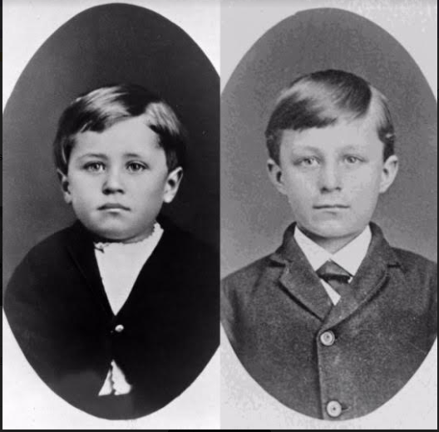

*Photo Credit: Library of Congress

**Wright Brothers Timeline**

|  |  |  |  |
| --- | --- | --- | --- |
| **December 17, 1903**  Orville flew the first plane with an engine 120 feet and 12 seconds | **April 16, 1867**  Wilbur Wright was born. | **1889**  Orville and Wilbur opened the Wright Brothers Print Shop and published The West Side News | **1932**  Orville helped with the unveiling of a marker at the Wright Brothers National Memorial. |
| **December 14, 1903**  Wilbur tried to fly the first plane with an engine and failed. | **1948**  Orville Wright died at age seventy-six after 2 heart attacks. | **August 19, 1871**  Orville Wright was born. | **December 17, 1903**  After 3 other successful flights that day Wilbur flew the best flight of the day lasting 59 seconds and going 852 feet! |
| **October 23, 1902**  Orville flew 622 feet and 26 seconds in a glider. A new world record is set! | **1899**  Orville began studying birds to get flight ideas. He also wrote the Smithsonian asking for any information on flight. They begin working on glider designs. | **May 25, 1910**  Milton Wright (Orville and Wilbur’s dad) took his first airplane flight with Orville. “Higher Orville, Higher,” said Milton. | **1885-1889**  Wilbur suffered a hockey injury. He lost several teeth and began having heart and stomach problems. His mom also got sick with tuberculosis and later dies. |
| **1908**  After refining their design Orville and Wilbur begin selling their planes. | **1892**  Wilbur and Orville opened their first bicycle shop and begin repairing and making bikes! | **1912**  Wilbur Wright died at the age of forty-five from Typhoid. Three years later Orville sold his part of the family business and retired. | **1900**  Wilbur and Orville make their first trip to Kitty Hawk and test their first glider. They flew it like a kite. |